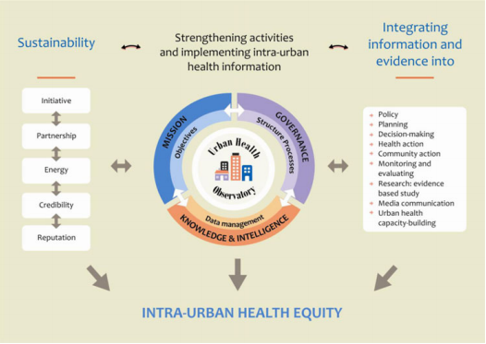
Figure 1. The Observatory framework and contextual dynamics (Caiaffa et al., 2014)

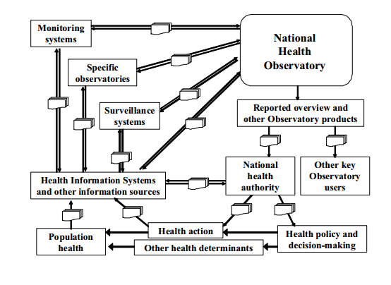
Figure 2. The role of a specific Observatory within a national health reporting system(PAHO, 2009)

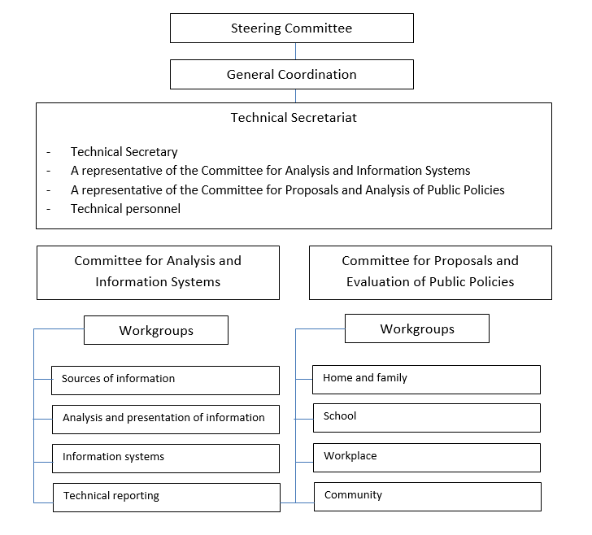
Figure 3. Example of the administrative structure of the Juarez municipal Observatory (Gutiérrez, Pacheco, Juárez, & Palacios, Luis Alexandro Cerqueira, 2012)

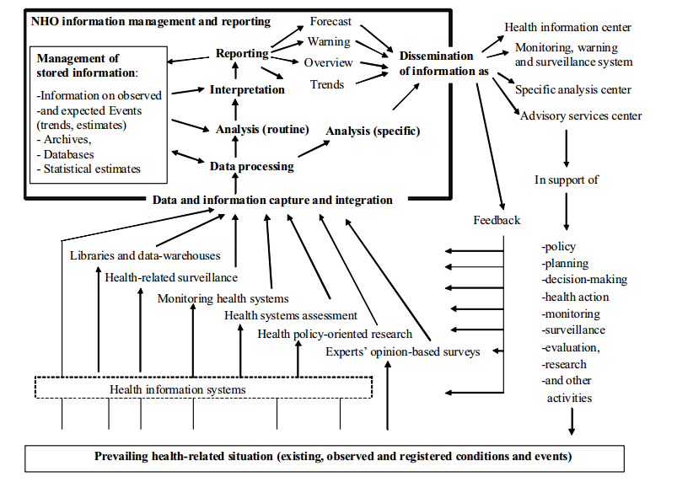
Figure 4. Observatory functions, information sources and management (PAHO, 2009)

