27th April 2020
Attention: The Editor-in-Chief
South African Journal of Occupational Therapy

Dear Editor-in-Chief
Manuscript Submission Title: Return to Work for people with Hand Injuries: Strategies and Barriers

The article attached is a quantitative study produced as part of a larger collaborative research project between the Universities of Cape Town and Stellenbosch. This article reports a descriptive cross-sectional study that aimed to establish the strategies occupational therapists use to facilitate the work-related transition process in people with hand injuries.

We feel this article is appropriate for the South African Journal of Occupational Therapy, as it has a direct bearing on occupational therapy service delivery in the field of work practice which fits the remit of the journal. Publication of the article will provide useful information about the different strategies used by occupational therapists to facilitate work-related transitions after sustaining a hand injury in the private and government sector of South Africa. As such, it provides a comprehensive picture of current practice patterns in this area. This article also highlights some of the barriers experienced by occupational therapists. It therefore contributes to the evidence base in this area by highlighting context-specific findings.
The content of this article has not been published elsewhere. The authors consent to this manuscript being published and are committed to being accountable for all aspects of this study. We declare that there are no competing interests. The Human Research Ethics Committee of the University of Stellenbosch (HREC reference number: S18/05/098) contact no: (021)938 9819 and the University of Cape Town (HREC reference number: 537/2018) contact no: (021)406 6338 have granted permission for this study. This work is based on the research supported wholly by the National Research Foundation of South Africa (GRANT NUMBER: TTK160525166179).
We look forward to hearing the outcome of this submission.
Yours sincerely,
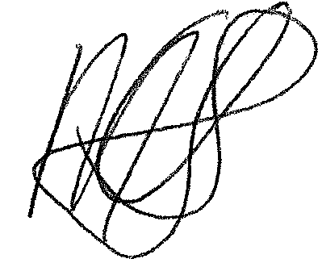  Corresponding Author (Ms Michelle Elizabeth Uys). Occupational Therapy Masters Student at Stellenbosch University. michelleelizabethuys@gmail.com |   Third Author (Dr Helen Buchanan). Associate Professor, Department of Health & Rehabilitation Sciences, University of Cape Town. helen.buchanan@uct.ac.za |   Second Author (Dr Lana Van Niekerk). Associate Professor, Department of Health & Rehabilitation Sciences, Stellenbosch University. lanavn@sun.ac.za

