Division Occupational Therapy

Department of Health and Rehabilitation Sciences

Faculty of Medicine and Health Science

Stellenbosch University

Cape Town, South Africa

6 September 2018

Dear Blanche Pretorius, Editor-in-Chief, South African Journal of Occupational Therapy

Re: Submission of feasibility study manuscript for review

Please accept this submission of a feasibility randomized pilot trial entitled: *Introducing early active mobilization following flexor tendon repair in a developing country context: A feasibility study.*

This trial design adheres to the CONSORT 2010 checklist for reporting a pilot or feasibility randomized trial and highlights important considerations in the feasibility of such trials within low resource settings. I have included the CONSORT checklist for this study, as a supplementary file.

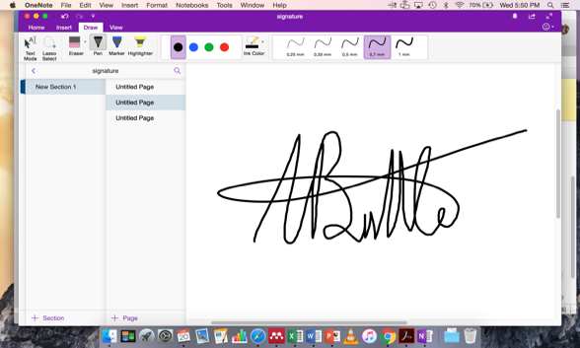Both authors have contributed to the conception and drafting of the manuscript and consent to publication. This manuscript has not been submitted elsewhere for publication. There are no conflicts of interest to declare. A. Buttle received the Ruth Watson Research Grant towards this trial in 2018.

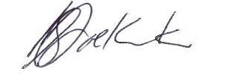

Amy Buttle Susan de Klerk

Sr. Occupational Therapist - Tygerberg Hospital Senior Lecturer

Masters of Occupational Therapy student Division of Occupational Therapy

Stellenbosch University Stellenbosch University

Cape Town, South Africa Cape Town, South Africa