13th June 2019
Attention: The Editor-in-Chief
South African Journal Occupational Therapy

Dear Editor-in-Chief
MANUSCRIPT SUBMISSION (TITLE): THE USE OF APPRECIATIVE INQUIRY WITH MENTAL HEALTH CONSUMERS – TOWARDS RESPONSIVE OCCUPATIONAL THERAPY PROGRAMS

The article attached is an Appreciative Inquiry framed in a social constructivist paradigm. The manuscript was produced as part of a collaborative effort between a fourth-year student at Stellenbosch University and an academic staff member. The manuscript aimed to use Appreciative Inquiry to explore the perspectives of outpatient mental healthcare consumers on the successful elements contained in an Occupational Therapy outpatient craft group. The study yielded valuable lessons for the use of participatory methodologies in occupational therapy. The delivery of responsive and appropriate occupational therapy programs requires the input of both the occupational therapy practitioner and the mental healthcare service user. From the study implications for clinicians are discussed.

The content of this article has not been published elsewhere. The article is deemed appropriate for the South African Journal of Occupational Therapy, as it focuses on the delivery of occupational therapy services for mental healthcare service users in a South African context. However, the methodology used may be transferable to a variety of contexts where other occupational therapy is deliver as an outpatient services to mental health users in tertiary mental health hospitals, which falls within the remit of the journal. Publication of the manuscript will provide insight into the use of an outpatient occupational therapy group from a mental healthcare service users’ perspective, in lower and-middle income countries with resource-constraints.

The authors consent to this manuscript being published and are committed to being accountable. We declare that there are no competing interests. The study received ethics clearance from the Human Research Ethics committee at Stellenbosch University (HREC ethics number U16/02/002). Funding was not required for the study. All three authors conceptualized, drafted and developed the manuscript.

The article meets the journal specification for Full-length manuscripts: the word count for the article itself is 4463 words, the abstract is 190 words, five tables, two figures and one addendum are included.
We look forward to hearing the outcome of this submission.
Yours sincerely,
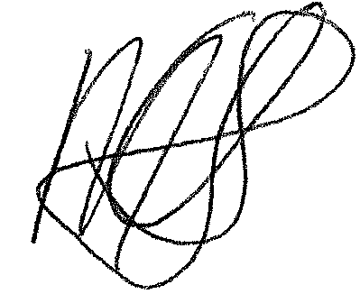
Corresponding Author (Ms Michelle Elizabeth Uys). Occupational Therapy Masters Student at Stellenbosch University. michelleelizabethuys@gmail.com; +27 729399527.

